ADAMHS Board   
of Cuyahog County

Faith-Based Program 2022 Annual Report

The table below shows the counts of the actual number of clients served and the projected/expected client counts for the year 2022 for the Faith-based provider programs. Note that there are several providers that have surpassed their expected client counts and the remainder were close to their expected annual total.

|  |  |  |
| --- | --- | --- |
| **Provider** | **# Individuals Served Q1-4** | **Expected Annual Total** |
| 99Treasures | 206 | 200 |
| Far West Center - Bridges | 28 | 45 |
| Far West Center - Mental Health First Aid | 21 | 24 |
| Galilean Theological Center | 53 | 40 |
| Kingdom Development Consulting | 89 | 150 |
| Naaleh Cleveland | 32 | 40 |
| NAMI Greater Cleveland -Education & Awareness Program | 133 | 90 |
| NAMI Greater Cleveland - Mental Health First Aid | 24 | 10 |
| OhioGuidestone | 103 | 115 |
| Trinity Outreach Ministries – Another Chance of Ohio | 330 | 150 |
| **Total** | **1,019** | **864** |

Due to program differences and ages of program participants, several measurement instruments are used. The DESSA instrument is designed for school age children. The DARS instrument is designed for adults. Both the DESSA and the DARS require an assessment at the beginning of a program as well as at the end of the program so that a measure of improvement can be shown. The Mental Health First Aid (MHFA) and the Awareness and Education Programs use quizzes to confirm that program participants have substantial knowledge about the program area.

|  |  |  |  |  |  |
| --- | --- | --- | --- | --- | --- |
|  | **# Individuals Served** | | | | |
| **Program Outcome Type** | Q1 | Q2 | Q3 | Q4 | Total |
| DESSA | 127 | 186 | 65 | 0 | 378 |
| DARS | 86 | 86 | 119 | 91 | 382 |
| MHFA | 0 | 23 | 11 | 11 | 45 |
| Awareness & Education | 53 | 85 | 33 | 43 | 214 |
| **Total** | **266** | **380** | **228** | **145** | **1,019** |

**Devereux Student Strengths Assessment (DESSA) Outcomes**

Faith-based programming for children K-12 grade is measured through the Devereux Student Strengths Assessment (DESSA) instrument by comparing a pre-assessment with a post-assessment. The DESSA web-based system is designed to help school and after-school program staff promote the healthy social-emotional development of all children. As there are differences between younger children and high school age children, two separate instruments have been developed for children in grades K-8 and the high school grades. The DESSA is a thorough assessment of the following social-emotional competencies:

Self-awareness; Social-awareness; Self-management; Relationship skills; Goal-directed behavior; Personal responsibility; Decision-making skills, and Optimistic thinking.

The scoring of the several competencies can be broken down into three categories:

1. “Strengths” showing children doing well
2. “Typical” positive behaviors for children
3. “Need for Instruction” to further develop social and emotional skills

Presently, the Board is receiving results of the DESSA MINI instrument that screens across the eight social-emotional competencies to identify generally whether children are in need for further social-emotional instruction. The expectation is that the programs provided by those faith-based service providers using the instrument will show growth in social-emotional maturity which may be attributed to their programs. The following charts show a breakdown of various measures collected from DESSA including numbers of DESSA submitted, numbers of clients having both the pre-assessment DESSA and the post program DESSA assessment, and changes from pre- to post-assessments.

**DESSA Submissions**

The chart below shows the number of clients who began services at each of the providers who planned to use the DESSA social emotional learning instrument.

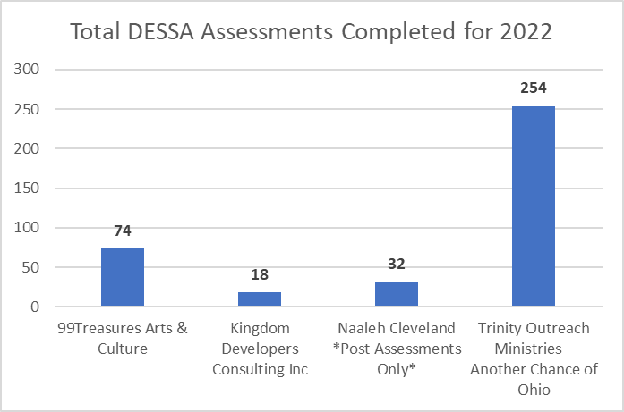

**DESSA Pre/Post Submissions**

The following includes counts of children who completed both pre- and post-assessments in a program for both the K-8 grades and high school grades combined. This chart shows all the completed assessments.

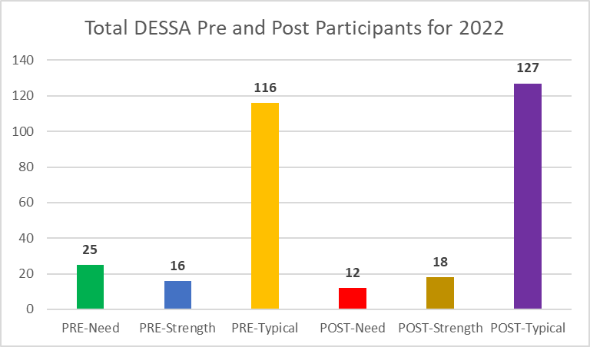

For those children who had both a pre-assessment and a post-assessment, the preceding chart shows the number of children in each of the three learning categories: need for instruction, typical, and strengths. There is a reduction from 25 to 12 children who are in the need category from pre- to post-assessment. There is an increase from 16 to 18 children in the strengths category. The typical category increased from 116 to 127 for pre- and post-assessments. The data shows that the programs are raising the level of social emotional learning for the children.

**DESSA Individual Agency Outcomes**

The following charts show counts for the pre- and post-assessments separately for each provider**.**

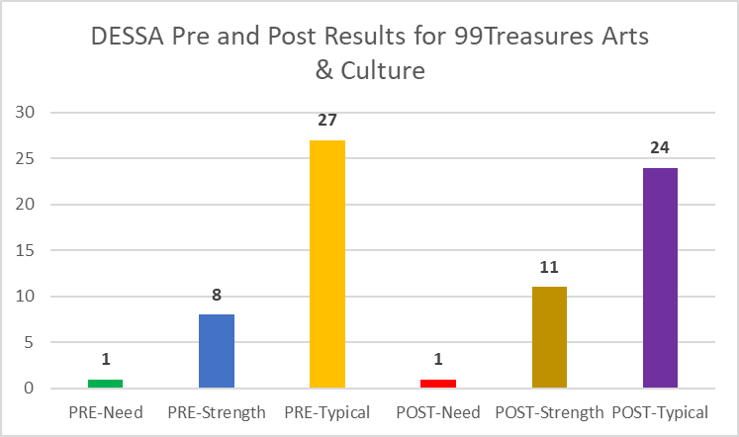

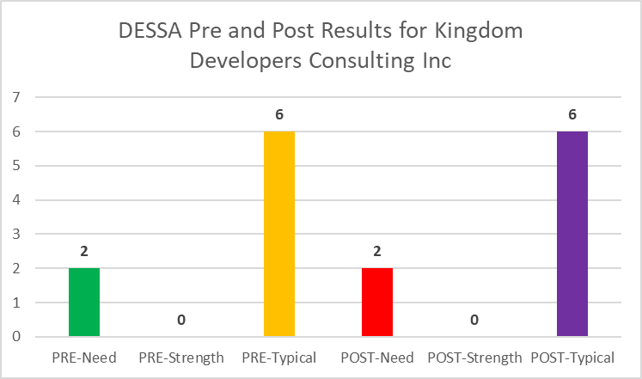

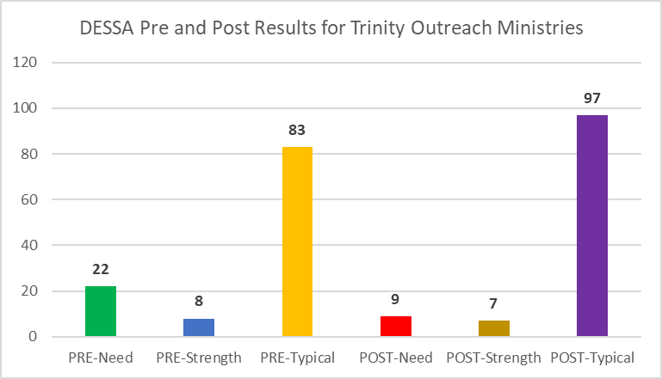

**Devereux Adult Resilience Survey (DARS) Outcomes**

The faith-based program for adults demonstrate resiliency measured as Always (A), Sometimes (S), or Not Yet (N) through the Devereux Adult Resilience Survey (DARS) instrument that promotes self-awareness regarding personal strengths to enhance creativity and the ability to set limits to cope with adversity and stress measured through the following areas:

* Will gain knowledge to develop healthy relationships
  + Will learn skills to increase self-worth to enhance internal beliefs and values
  + Will learn strategies to develop/enhance self-motivation to increase independence
  + Will learn how to self-regulate and control without the use of substances and negative influences.

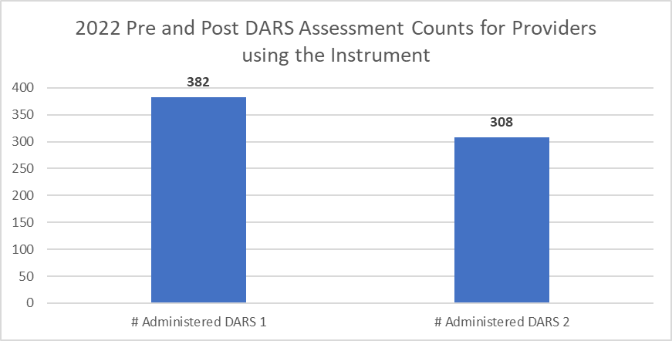

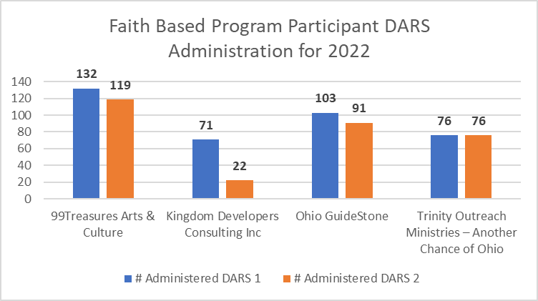

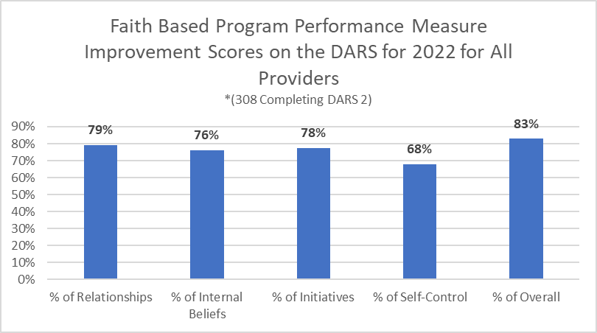

**DARS Individual Agency Outcomes**

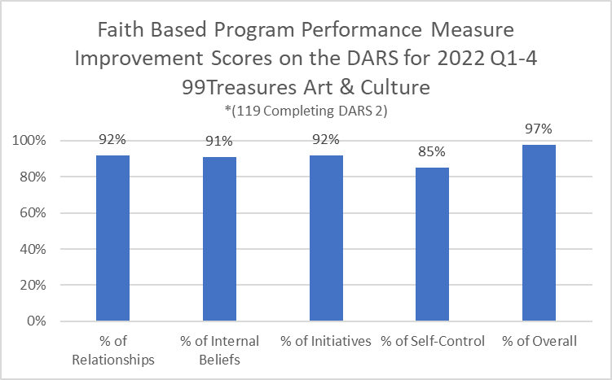

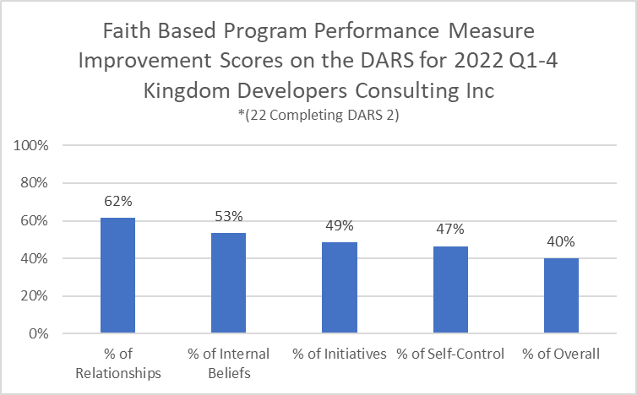

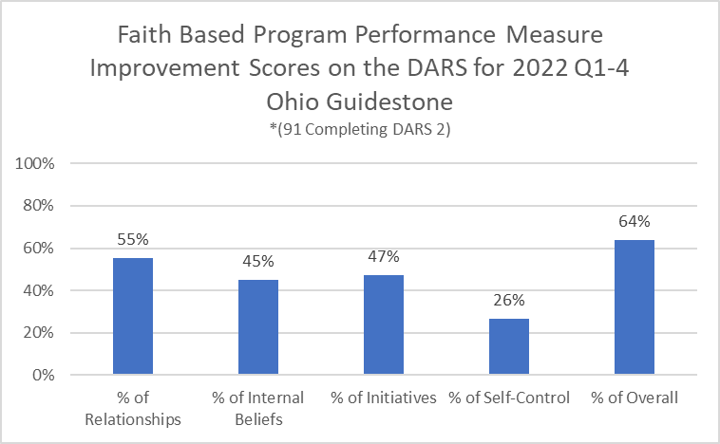

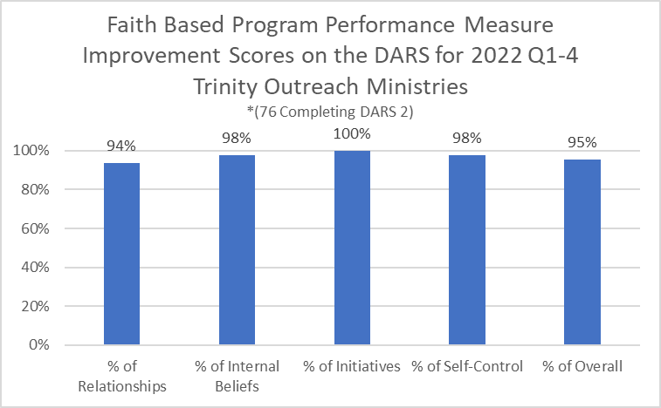

**Mental Health First Aid Individual Agency Outcomes**

Mental Health First Aid is designed to teach individuals how to spot the signs and symptoms of mental illness and provide help on a first-aid basis. Individuals who are participating in a Mental Health First Aid training provided by a faith-based program provider is expected to successfully complete the course evaluation/quiz and score at least 60% based on the following topics**:**

* Helpful Things to Say
* Myths and Facts - Suicide and Self-Injury
* Suicidal Thoughts and Behaviors
* Panic Attacks
* Traumatic Events
* Auditory Hallucinations
* Psychosis
* Substance Use Disorders

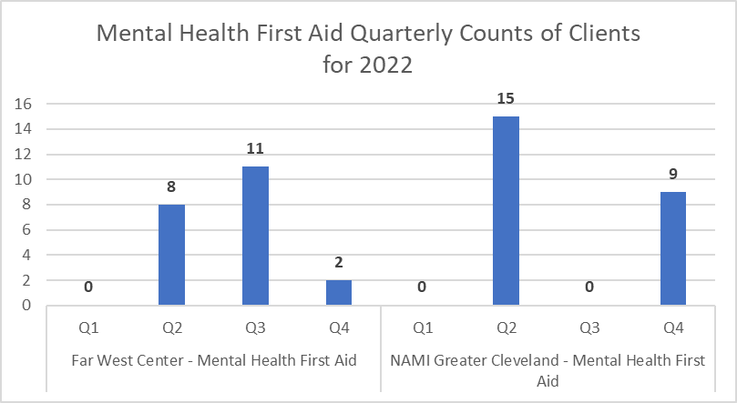

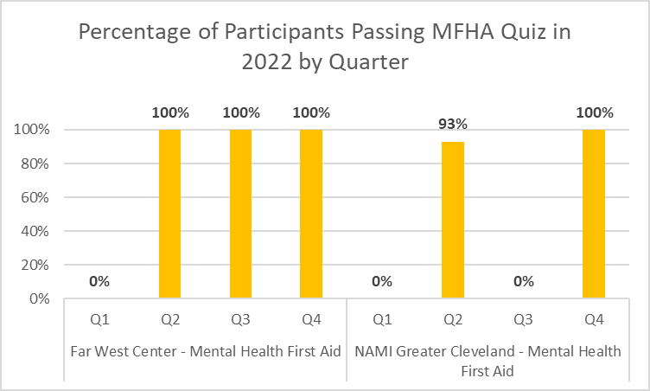

**Education and Awareness Outcomes**

* Far West Center - Building bridges between the faith community and behavioral health providers.
* NAMI Cleveland - Providing mental health education and support within faith-based communities for individuals with mental illness and their families.
* Galilean Theological Center – Providing Education and Awareness Training for Latinx Pastors.

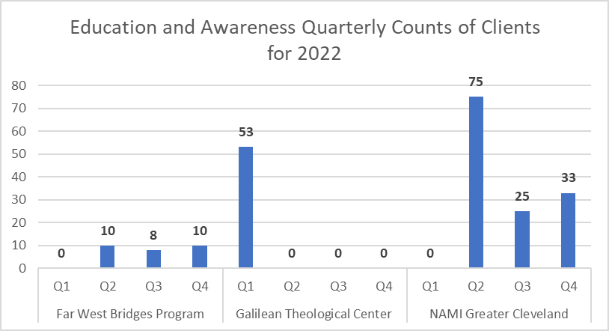

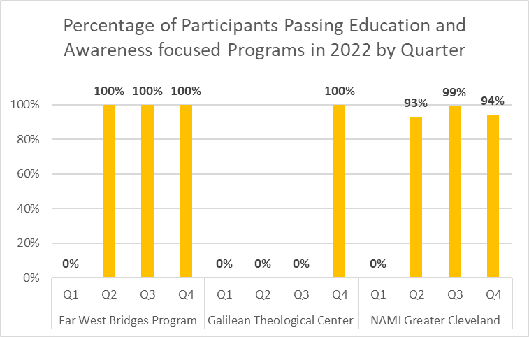

Note that the Galilean Theological Center program is a continuing cohort of pastors, who are counted only in their first quarter of participation.